Day 1 – Practical Session
Course Code: DSA0612
Course: Data Handling and Visualization
1. Visualize Scatter plot for given dataset.
Weight (kg) | Height (cm)
60 | 170
65 | 175
70 | 168
72 | 180
75 | 178

Sample Code:

weight=c(60,65,70,72,75)
height=c(170,175,168,180,178)
plot(weight,height,main="weight vs height",col="red",pch=16)

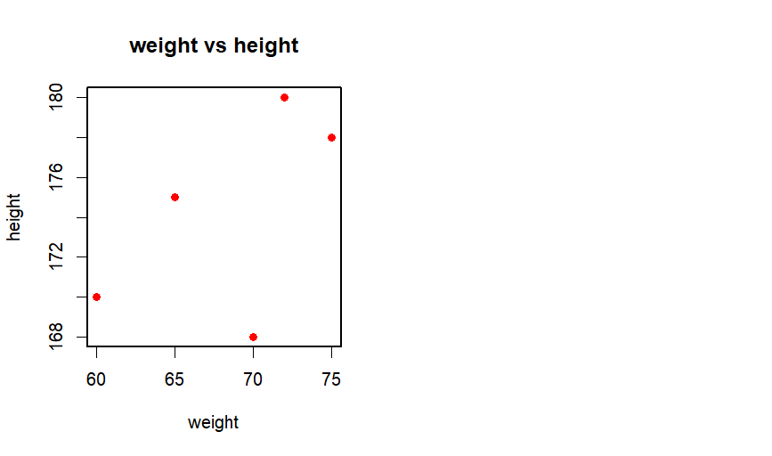
2. Visualize a Line Plot for the Given Population Data
Year | Population (millions)
2010 | 1000
2011 | 1020
2012 | 1040
2013 | 1060
2014 | 1080

population=c(1000,1020,1040,1060,1080)
year=c(2010,2011,2012,2013,2014)
plot(year,population,main="year vs population",type="l",col="green",pch=16,lwd=2)

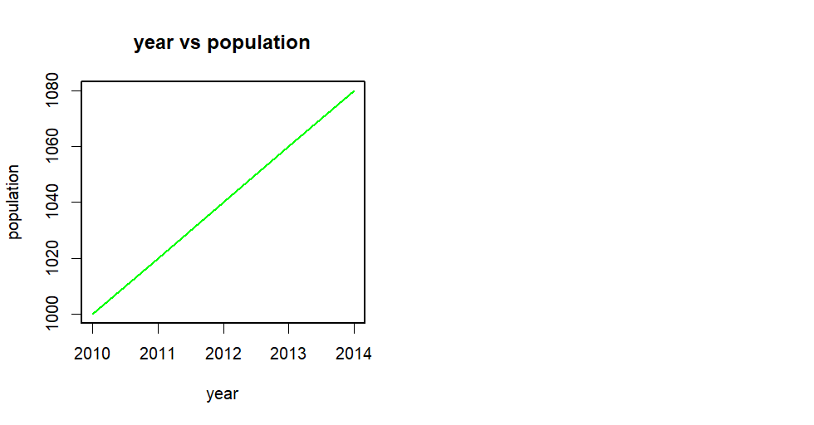

3. Bar Plot
Dataset: Sales by Product
Product | Sales
A | 300
B | 450
C | 500
D | 350
E | 400

product=c("A","B","C","D","E")
Sales=c(300,450,500,350,400)
par(lwd = 2)
barplot(Sales,names.arg=product,main="sales vs product",col="lightblue",border="blue")

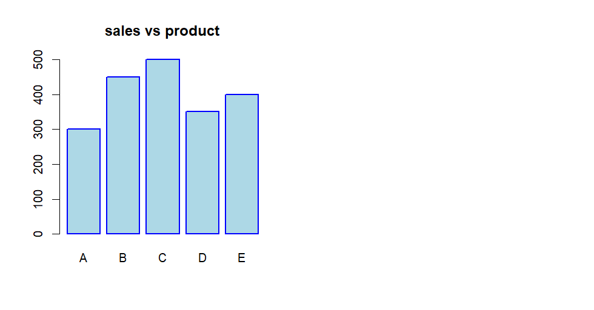

4. Histogram
Dataset: Age Distribution
Age

25

30

35

40

45

50

55

60

65

70

age <- c(25, 30, 35, 40, 45, 50, 55, 60, 65, 70)
hist(age, main = "Histogram for Age",ylab = "Frequency",col = "yellow", border="black")
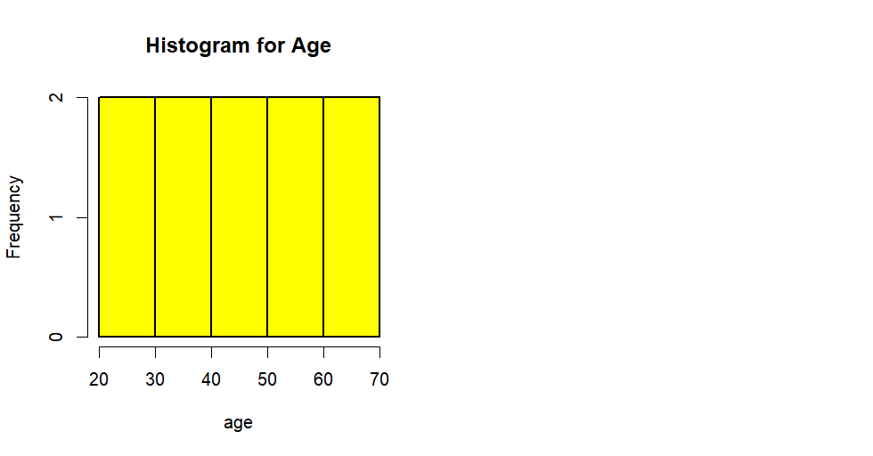
5. Pie Chart
Dataset: Market Share by Company
Company | Market Share
A | 20%
B | 30%
C | 25%
D | 25%

Company <- c("A", "B", "C", "D")
Market <- c(20, 30, 25, 25)
percentages <- round(Market / sum(Market) * 100, 1)
pie(Market, labels = paste(Company, percentages, "%"), main = "Market Share by Company", col = c("red","blue","green","yellow"))

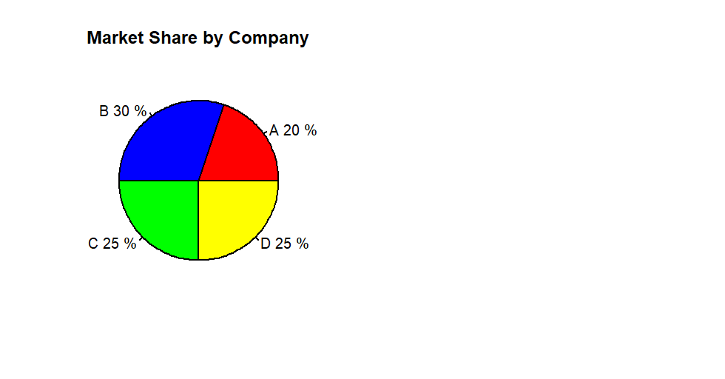
6. Box Plot
Dataset: Exam Scores by Class
Class | Scores
A | 85
A | 90
A | 78
A | 92
B | 88
B | 76
B | 80
B | 84

Class <- c("A", "A", "A", "A", "B", "B", "B", "B")
Scores <- c(85, 90, 78, 92, 88, 76, 80, 84)
boxplot(Scores~Class, main = "Boxplot of Scores by Class",
col = c("lightblue","lightgreen"))

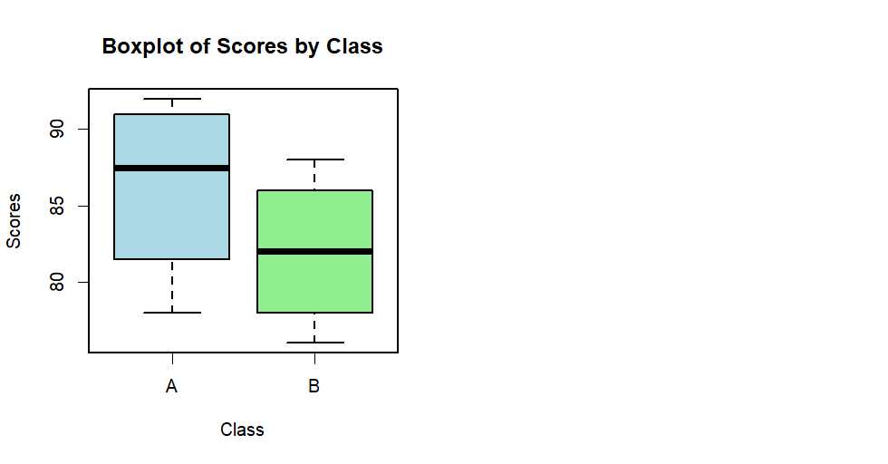
7. Density Plot
Dataset: Weights of Individuals
Weight (kg)

60

65

70

75

80

85

90

95

100

Weight <- c(60, 65, 70, 75, 80, 85, 90, 95, 100)
plot(density(Weight), main = "Density Plot for Weight",
xlab = "Weight", ylab = "Density",
col = "purple",lwd=2)

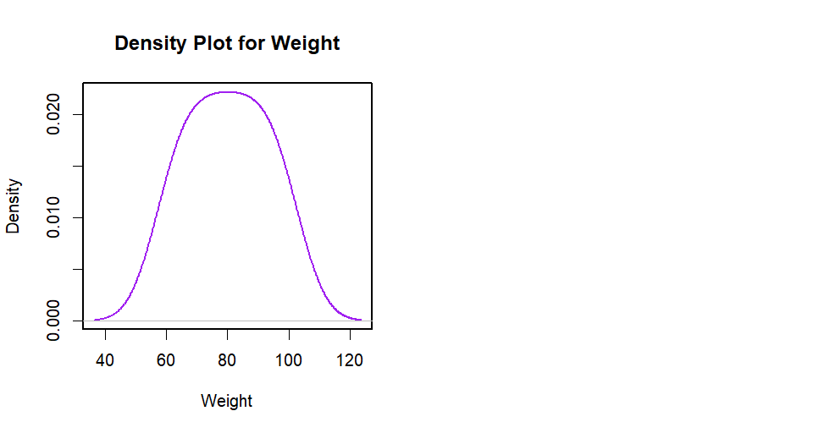
8. Violin Plot
Dataset: Scores by Group
Group | Score
X | 80
X | 85
X | 78
X | 92
Y | 88
Y | 76
Y | 80
Y | 84
library(vioplot)
Group <- c("X", "X", "X", "X", "Y", "Y", "Y", "Y")
Score <- c(80, 85, 78, 92, 88, 76, 80, 84)
vioplot(Score[Group == "X"], Score[Group == "Y"],
names = c("Group X", "Group Y"),
col = c("orange", "yellow"),
main = "Violin Plot of Scores by Group",
xlab = "Group",ylab="Score")

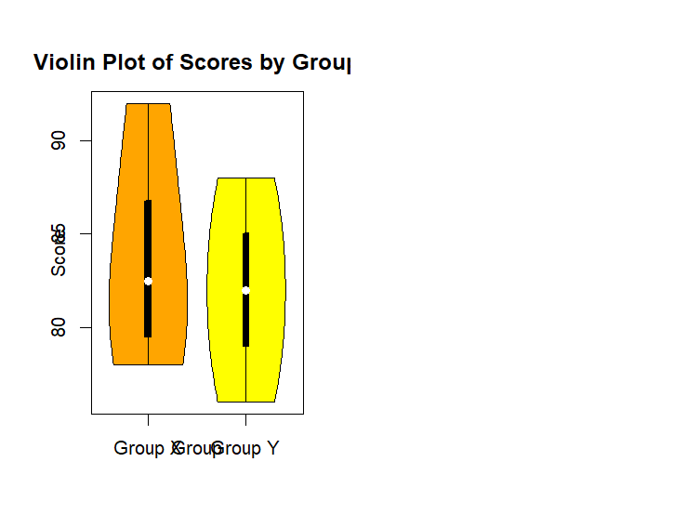

9. Heatmap
Dataset: Monthly Temperatures
Month | City A | City B | City C
Jan | 5 | 10 | 15
Feb | 6 | 11 | 16
Mar | 7 | 12 | 17
Apr | 8 | 13 | 18
May | 9 | 14 | 19

temperature_data <- data.frame(
Month = c("Jan", "Feb", "Mar", "Apr", "May"),
city_a = c(5, 6, 7, 8, 9),
city_b = c(10, 11, 12, 13, 14),
city_c = c(15, 16, 17, 18, 19)
)
rownames(temperature_data) <- temperature_data$Month
temperature_data <- temperature_data[, -1]
heatmap(as.matrix(temperature_data),
main = "Temperature Heatmap",
xlab = "Cities", ylab = "Months",
col = heat.colors(256), scale = "column",
margins = c(5, 10),
cexRow = 1.2,
cexCol = 1.2,
las=2)
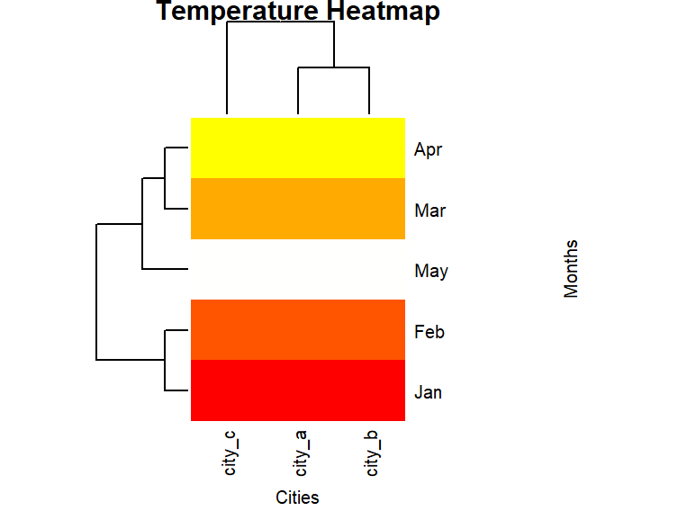

10. Facet Plot
Dataset: Sales by Month and Region
Month | Region | Sales
Jan | East | 200
Jan | West | 150
Feb | East | 220
Feb | West | 170
Mar | East | 210
Mar | West | 160

Sales_data <- data.frame(
Month = c("Jan", "Jan", "Feb", "Feb", "Mar", "Mar"),
Region = c("East", "West", "East", "West", "East", "West"),
Sales = c(200, 150, 220, 170, 210, 160)
)
par(mfrow = c(1, 2))
east_sales <- Sales_data[Sales_data$Region == "East", ]
barplot(east_sales$Sales, names.arg = east_sales$Month,
main = "East Region Sales", xlab = "Month", ylab = "Sales", col = "pink")
west_sales <- Sales_data[Sales_data$Region == "West", ]
barplot(west_sales$Sales, names.arg = west_sales$Month,
main = "West Region Sales", xlab = "Month", ylab = "Sales",col="yellow")

